**Operating Systems Lab-6**

**Process Creation, Execution and Termination**



Submitted By: **Awais Saddiqui**

Registration# **21pwcse1993**

Section: **“A”**

Submitted to:

**Mam Madiha Sher**

**Department of Computer Systems Engineering**

**University of Engineering and Technology, Peshawar.**

**CSE 302L:** **Operating Systems Lab**

**LAB ASSESSMENT RUBRICS**

|  |  |  |  |  |
| --- | --- | --- | --- | --- |
| **Marking Criteria** | **Exceeds expectation**  **(2.5)** | **Meets expectation**  **(1.5)** | **Does not meet expectation**  **(0)** | **Score** |
| 1. **Correctness** | Program compiles (no errors and no warnings).  Program always works correctly and meets the specification(s).  Completed between 81-100% of the requirements. | Program compiles (no errors and some warnings).  Some details of the program specification are violated, program functions incorrectly for some inputs.  Completed between 41-80% of the requirements. | Program fails to or compile with lots of warnings.  Program only functions correctly in very limited cases or not at all.  Completed less than 40% of the requirements. |  |
| 1. **Delivery** | Delivered on time, and in correct format (disk, email, hard copy etc.) | Not delivered on time, or slightly incorrect format. | Not delivered on time or not in correct format. |  |
| 1. **Coding Standards** | Proper indentation, whitespace, line length, wrapping, comments and references. | Missing some of whitespace, line length, wrapping, comments or references. | Poor use of whitespace, line length, wrapping, comments and references. |  |
| 1. **Presentation of document** | Includes name, date, and assignment title. Task titles, objectives, output screenshots included and good formatting and excellently organized. | Includes name, date, and assignment title.  Task titles, objectives, output screenshots included and good formatting. | No name, date, or assignment title included.  No task titles, no objectives, no output screenshots, poor formatting. |  |

**Instructor:**

Name: __Engr. Madiha Sher___ Signature: ______________________

**Operating Systems Lab**

**What is a Process Creation :**

Process creation is the act of creating a new process. A process is a unit of execution in an operating system. It is a program in execution with its own address space, stack, registers, and resources.

**What is a Process execution:**

Process execution is the act of carrying out a process. It is the process of taking a set of instructions and carrying them out in order to achieve a specific outcome. Process execution can be manual or automated.

**What is a Process Termination:**

Process termination is the end of a process's life cycle. It can happen for a variety of reasons, such as the process reaching the end of its code, receiving a signal, or being killed by the operating system.

**Orphan Process:**

If a parent dies before its child, the child (orphan process) is automatically adopted by the original “init” process whose PID is 1.

**Objectives:**

This lab describes how a program can create, terminate, and control child processes. Actually, there are a few distinct operations involved: creating a new child process, and coordinating the completion of the child process with the original program.

**Task #1:**

Write a C program that executes ls -l command in the child process. Parent process shall wait for the child process.

**Code:**

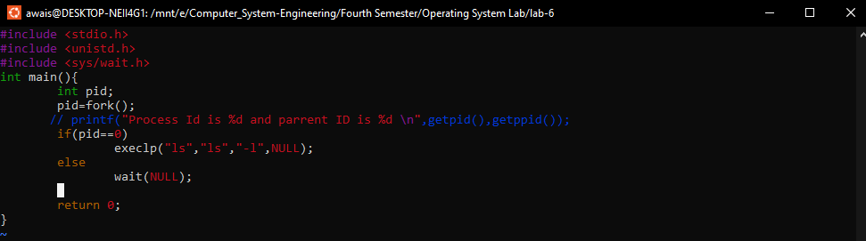

**Output:**

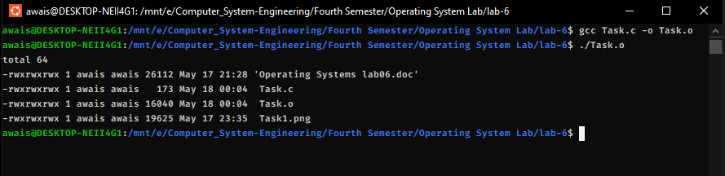

**Task #2:**

1. **Write a C program that finds the max of an array.**
2. **Write a C program that creates a child process and executes the above program in child process. Parent shall wait for the child process.**

**Code:**

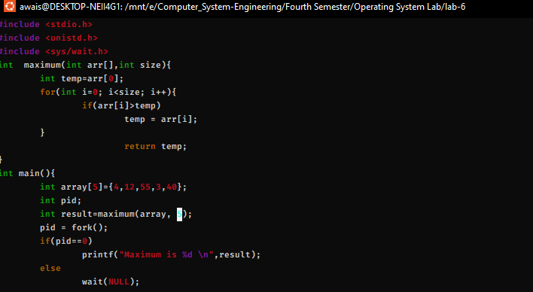

**Output:**



**Task #3:**

**Create a fan of N processes. Take N as input from the user. Make sure there are no orphan processes.**

**Code:**

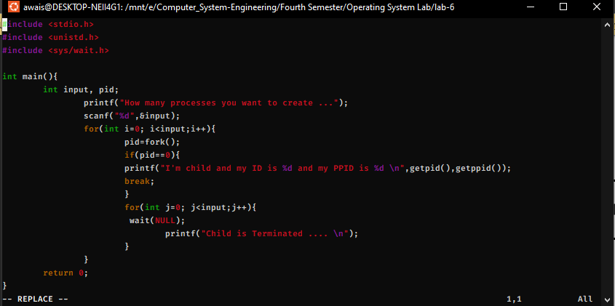

**Output:**

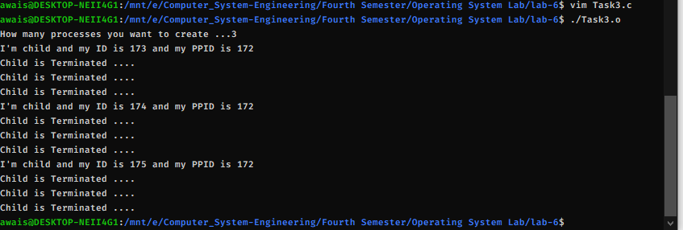

**Task #4:**

**Create a chain of N processes. Take N as input from user. Make sure there are no orphan processes.**

**Code:**

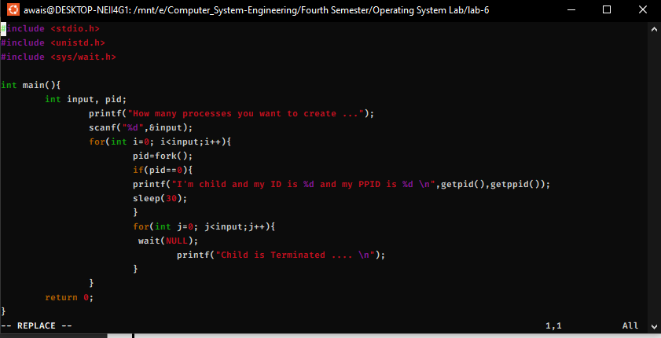

**Output:**

